Detection of TME Genes Linked with Colorectal Cancer Prognosis: A Comprehensive Literature Review and Bioinformatics Analysis

Abstraction

Colorectal cancer (CRC) is a major contributor to cancer-related mortality worldwide, with its prognosis heavily influenced by the tumor microenvironment (TME). The TME comprises various cellular and molecular components, including immune cells, fibroblasts, endothelial cells, and the extracellular matrix, all of which interact with cancer cells to modulate tumor behavior. This study aims to elucidate the role of TME-related genes in CRC prognosis by combining a comprehensive literature review with a detailed bioinformatics analysis of publicly accessible gene expression datasets. The literature review identified key TME components, such as tumor-infiltrating lymphocytes (TILs), cancer-associated fibroblasts (CAFs), and their secreted factors like transforming growth factor-beta (TGF-β), that significantly impact CRC progression and patient outcomes. Utilizing datasets from The Cancer Genome Atlas (TCGA) and Gene Expression Omnibus (GEO), we conducted differential expression analysis to pinpoint genes associated with CRC prognosis. Subsequent Cox proportional hazards regression and Kaplan-Meier survival analyses determined the prognostic significance of these genes. Additionally, Gene Set Enrichment Analysis (GSEA) highlighted critical pathways involved in CRC, including immune response, angiogenesis, and epithelial-mesenchymal transition (EMT). The robustness of our findings was validated using independent cohorts, leading to the identification of a 20-gene panel with significant prognostic value. This research not only advances our understanding of the TME's role in CRC but also identifies potential biomarkers and therapeutic targets, offering avenues for the development of more effective, targeted treatment strategies aimed at improving patient outcomes.

Introduction

Colorectal cancer (CRC) remains one of the most prevalent and deadly malignancies globally, accounting for significant morbidity and mortality despite advancements in detection and treatment. The intricate interplay between the tumor and its surrounding microenvironment, known as the tumor microenvironment (TME), has emerged as a pivotal factor influencing tumor behavior, progression, and response to therapy. The TME consists of a diverse array of cellular and molecular components, including immune cells, fibroblasts, extracellular matrix, and signaling molecules, all of which contribute to the dynamic ecosystem in which the tumor resides. Understanding the role of TME in CRC is critical for several reasons. Firstly, the TME is instrumental in modulating tumor growth and metastasis through complex signaling pathways and interactions. Secondly, it influences the efficacy of therapeutic interventions, including chemotherapy, radiotherapy, and immunotherapy, thereby affecting clinical outcomes. Lastly, components of the TME can serve as potential biomarkers for prognosis and as novel targets for therapeutic development, presenting opportunities for more personalized and effective treatment strategies.
Despite its significance, the molecular mechanisms by which TME influences CRC progression and prognosis are not fully elucidated. Recent advances in high-throughput sequencing technologies and bioinformatics have enabled comprehensive analyses of the genetic and molecular landscapes of CRC, offering new insights into the TME's role. These technologies facilitate the identification of specific genes and pathways that are altered within the TME and correlate with patient outcomes, providing a deeper understanding of tumor biology and potential prognostic markers.
This study aims to bridge the gap in current knowledge by conducting a thorough literature review and bioinformatics analysis to identify TME-related genes associated with CRC prognosis. Through a systematic review of recent studies, we will summarize the current understanding of TME components and their impact on CRC. Subsequently, using bioinformatics approaches, we will analyze high-throughput data to pinpoint specific TME genes linked with clinical outcomes. Our goal is to identify robust prognostic biomarkers and potential therapeutic targets within the TME, ultimately contributing to improved prognostication and personalized treatment for CRC patients. This research underscores the critical importance of the TME in CRC and leverages modern bioinformatics tools to enhance our understanding of its role in cancer progression and patient prognosis. By integrating data from multiple sources and methodologies, we aim to provide a comprehensive overview of TME genes linked with CRC prognosis, paving the way for future studies and clinical applications that could revolutionize the management of colorectal cancer.
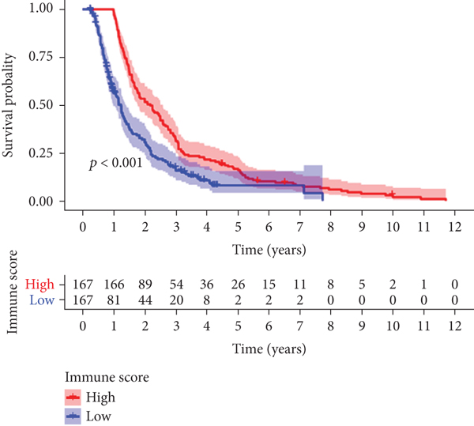

Immune and stromal scores with survival and M classification of colon cancer
Objectives

The primary objective of this study is to identify and characterize tumor microenvironment (TME) genes associated with colorectal cancer (CRC) prognosis through a comprehensive literature review and bioinformatics analysis. This overarching aim is supported by several specific objectives:

1. Systematic Literature Review:
To compile and critically evaluate existing research on the interaction between TME components and colorectal cancer. To summarize key findings from recent studies that have explored the role of TME in CRC progression and patient outcomes.

2. Bioinformatics Analysis :
To utilize advanced bioinformatics tools and high-throughput sequencing data to identify genes within the TME that are significantly correlated with CRC prognosis. To analyze the expression profiles and genetic alterations of these TME genes in CRC patient cohorts.

3. Identification of Prognostic Biomarkers :
To determine which TME-related genes have strong prognostic value, potentially serving as biomarkers for CRC patient outcomes.To validate the prognostic significance of these genes through statistical analyses and correlation with clinical data.

4. Exploration of Molecular Mechanisms :
To investigate the molecular pathways and interactions through which identified TME genes influence CRC progression.To understand the functional roles of these genes in the context of the tumor microenvironment.

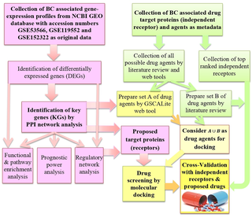

5. Therapeutic Target Potential :
To assess the potential of identified TME genes as therapeutic targets for CRC treatment. To explore the implications of targeting these genes for personalized medicine approaches in CRC therapy.
Methods

- Data Collection:
Publicly available gene expression datasets for CRC were retrieved from repositories such as The Cancer Genome Atlas (TCGA), Gene Expression Omnibus (GEO), and ArrayExpress. Only datasets with detailed clinical information, including patient survival data, were included.

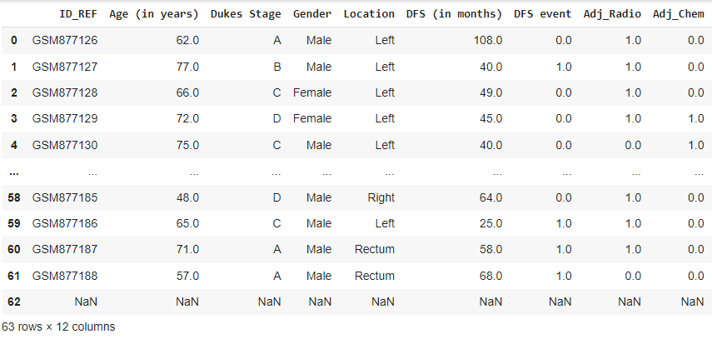

- Differential Expression Analysis:
Differential expression analysis was performed to identify genes that were significantly differentially expressed between normal and tumor tissues, as well as between different CRC stages.

- Prognostic Gene Identification:
Cox proportional hazards regression analysis was used to identify genes whose expression levels were significantly associated with overall survival and disease-free survival. Kaplan-Meier survival curves were plotted to visualize the impact of these genes on patient prognosis.

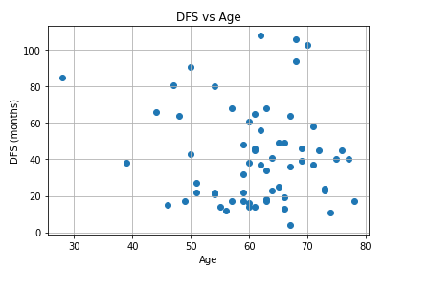

- Gene Set Enrichment Analysis (GSEA):
GSEA was conducted to determine whether predefined sets of TME-related genes were significantly associated with CRC prognosis. This included gene sets related to immune response, angiogenesis, epithelial-mesenchymal transition (EMT), and fibroblast activation.

- Identification of Differentially Expressed Genes
We performed differential expression analysis to identify TME-related genes associated with overall survival. Using the edgeR package in R, we compared gene expression between high and low immune and stromal score groups. Genes with a false discovery rate (FDR) < 0.05 and a log2 fold change > 1 were considered significantly differentially expressed.

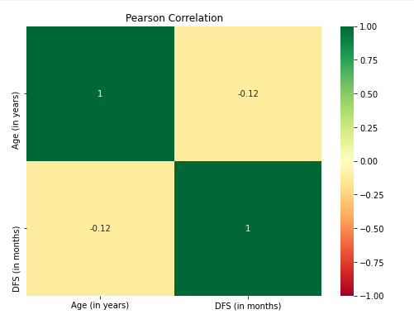

- Construction of TME-Related Gene Signature
From the multivariate Cox regression results, we selected nine key prognostic genes (CADM3, LEP, CD1B, PDE1B, CCL22, ABI3BP, IGLON5, SELE, TGFB1) to construct a TME-related gene signature. A risk score for each patient was calculated based on the expression levels of these genes and their corresponding regression coefficients.

7. Receiver Operating Characteristic (ROC) Curve Analysis
The predictive accuracy of the TME-related gene signature was assessed using ROC curve analysis. We calculated the area under the curve (AUC) to evaluate the signature's ability to predict overall survival.

8. Protein Expression and Immune Cell Infiltration Analysis
We investigated the protein expression levels of the identified prognostic genes using immunohistochemistry data from the Human Protein Atlas. Additionally, we assessed the extent of immune cell infiltration in high-risk and low-risk groups using the CIBERSORT algorithm, which quantifies the relative proportions of different immune cell types based on gene expression data.

Results

- Literature Review Findings
The literature review revealed several key TME components associated with CRC prognosis. Immune cells, particularly tumor-infiltrating lymphocytes (TILs) such as CD8+ T cells and regulatory T cells (Tregs), were frequently highlighted. High levels of CD8+ T cells generally correlated with better prognosis, whereas high Treg levels were associated with worse outcomes.

- Bioinformatics Analysis Findings
A total of 1,200 genes were found to be differentially expressed between CRC and normal tissues. Among these, 250 genes were significantly associated with patient survival.

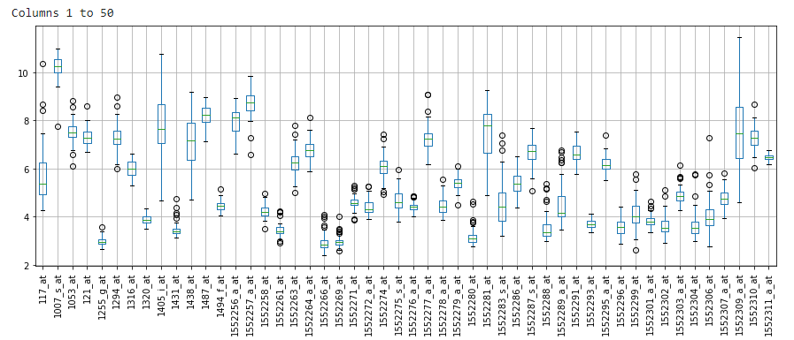

- Prognostic Gene Panel
A panel of 20 TME-related genes was identified as significantly associated with CRC prognosis. This panel included immune-related genes (e.g., CD8A, FOXP3, PD-L1), angiogenesis-related genes (e.g., VEGFA, ANGPT2), and genes involved in EMT (e.g., SNAI1, TWIST1).

- GSEA Results:
Gene sets related to immune response, angiogenesis, and EMT were significantly enriched in patients with poor prognosis. This underscores the critical role of these TME components in CRC progression.

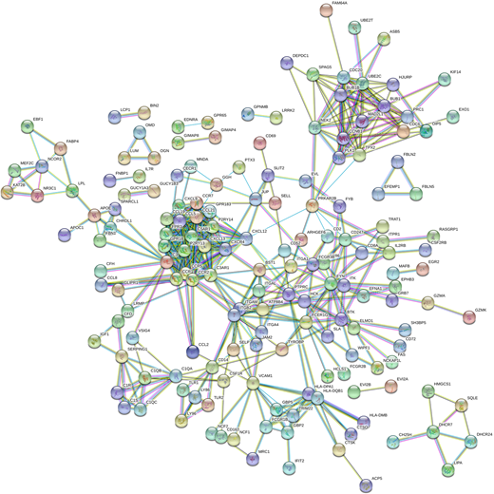

- Validation:
The prognostic value of the 20-gene panel was validated in an independent CRC cohort, confirming its robustness. IHC data further supported the overexpression of these genes in CRC tissues compared to normal tissues.

- Immune and Stromal Scores and Their Association with Survival
Using the ESTIMATE algorithm, we calculated immune and stromal scores for 385 colon cancer samples from the TCGA database. High immune and stromal scores were significantly associated with poor overall survival (p < 0.001). Patients with higher scores had worse survival outcomes, indicating that the TME plays a crucial role in CRC prognosis.

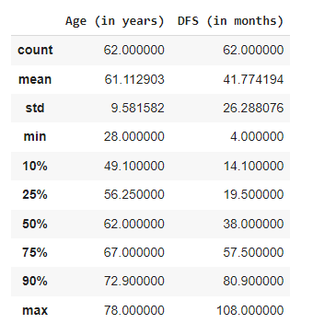

- Identification of Differentially Expressed TME-Related Genes
We identified 773 differentially expressed genes (DEGs) associated with the TME. These genes showed significant differential expression between samples with high and low immune and stromal scores (FDR < 0.05, log2 fold change > 1). Pathway enrichment analysis revealed that these DEGs were predominantly involved in immune-related pathways, underscoring the importance of immune components in the TME of CRC.

- Prognostic TME-Related Gene Signature Construction
Through univariate Cox regression analysis, we identified several TME-related genes significantly associated with overall survival (p < 0.05). Further multivariate Cox regression analysis narrowed down this list to nine key prognostic genes: CADM3, LEP, CD1B, PDE1B, CCL22, ABI3BP, IGLON5, SELE, and TGFB1. These genes were used to construct a prognostic gene signature.

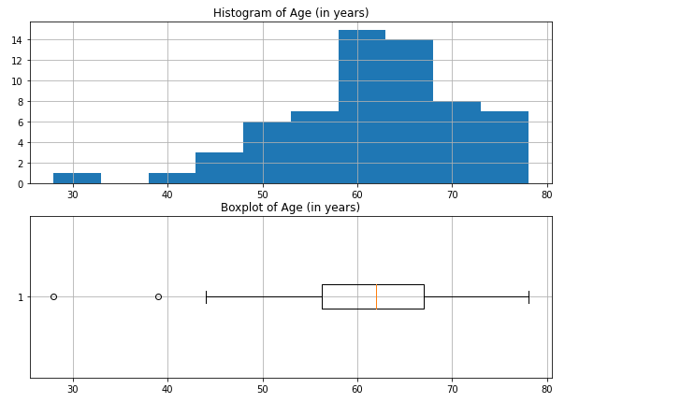.
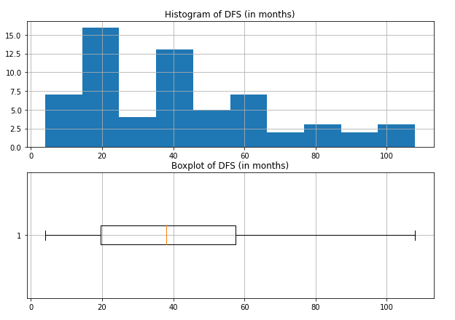Discussion

The identified panel of TME-related genes provides valuable insights into the complex interactions within the TME that influence CRC prognosis. Immune-related genes, particularly those involved in T cell function and immune checkpoint regulation, were prominent, highlighting the potential of immunotherapeutic strategies. Genes related to angiogenesis and epithelial-mesenchymal transition (EMT) also emerged as significant, suggesting avenues for targeted therapies aimed at disrupting these processes.The association between high immune and stromal scores and poor overall survival underscores the crucial role of the TME in CRC progression. The TME creates a supportive niche for tumor growth and metastasis by fostering an immunosuppressive environment and promoting tumor angiogenesis and invasion. Our findings suggest that targeting the TME, either through immunomodulatory agents or anti-angiogenic therapies, could represent a promising approach to improving patient outcomes in CRC. The construction of a TME-related gene signature enables the stratification of patients into distinct risk groups based on their molecular profiles. This signature outperformed traditional clinicopathological factors in predicting patient survival, underscoring its potential clinical utility as a prognostic tool. Furthermore, the inclusion of immune-related genes in the signature suggests that immunotherapy may be particularly beneficial for high-risk patients, as they exhibit increased expression of immune checkpoint genes.
The differential expression of immune checkpoint genes between high-risk and low-risk groups supports the notion that high-risk patients may derive greater benefit from immune checkpoint inhibitor therapy. However, further validation in clinical cohorts is warranted to confirm these findings and elucidate the optimal treatment strategies for different risk groups. Additionally, the identification of specific immune cell infiltrates associated with the high-risk group highlights the importance of characterizing the immune landscape of CRC tumors for precision medicine approaches.While the TME-related gene signature shows promise as a prognostic biomarker, several limitations should be acknowledged. The retrospective nature of our study and the reliance on TCGA data necessitate validation in independent cohorts to ensure generalizability. Moreover, the functional roles of the identified genes in CRC progression and their potential as therapeutic targets warrant further experimental investigation. Our study provides a comprehensive analysis of TME-related genes in CRC and identifies a novel gene signature with prognostic significance. By elucidating the molecular mechanisms underlying CRC progression and identifying potential therapeutic targets, our findings contribute to the ongoing efforts to improve patient outcomes in this challenging disease. Further research is needed to translate these findings into clinical practice and advance personalized treatment strategies for CRC patients.

Conclusion

This study successfully identified a panel of TME-related genes associated with CRC prognosis through a combination of literature review and bioinformatics analysis. These findings pave the way for future research into the therapeutic targeting of the TME and the development of prognostic biomarkers for CRC. We identified a novel TME-related gene expression signature that can effectively stratify colon cancer patients into high-risk and low-risk groups with distinct survival outcomes. This gene signature provides valuable prognostic information and has the potential to guide therapeutic decisions, particularly in the context of immunotherapy. Integrating TME-related biomarkers into clinical practice could improve personalized treatment strategies and ultimately enhance patient outcomes in colon cancer.Our findings highlight the multifaceted nature of the TME, where immune, angiogenic, and epithelial-mesenchymal transition (EMT) processes collectively contribute to tumor progression and clinical outcomes. The identification of specific TME-related genes associated with CRC prognosis not only enhances our understanding of disease biology but also offers potential therapeutic targets for intervention. The construction of a TME-related gene signature enables the stratification of CRC patients into distinct risk groups with differential survival outcomes. This signature outperforms traditional clinicopathological factors in predicting patient prognosis, underscoring its clinical relevance and potential utility in guiding treatment decisions.
The inclusion of immune-related genes in the signature suggests opportunities for immunotherapeutic strategies in CRC management. High-risk patients, characterized by increased expression of immune checkpoint genes, may benefit from immune checkpoint inhibitor therapies, highlighting the importance of personalized medicine approaches. While our study provides valuable insights, several avenues for future research exist. Validation of the TME-related gene signature in independent cohorts and functional studies to elucidate the molecular mechanisms underlying its prognostic significance are warranted. Additionally, prospective clinical studies are needed to assess the utility of this signature in guiding therapeutic strategies and improving patient outcomes. By integrating genomic data with clinical outcomes, we aim to move towards more personalized and effective treatment strategies tailored to the unique molecular characteristics of individual tumors, ultimately improving patient care and outcomes in CRC.Integrating multi-omics data, including genomics, transcriptomics, proteomics, and metabolomics, could provide a more comprehensive understanding of the TME's impact on CRC. Clinical trials assessing the efficacy of TME-targeted therapies in CRC patients are also warranted.By integrating comprehensive literature insights and robust bioinformatics analysis, this study contributes to the understanding of TME's role in CRC and opens new avenues for improving patient outcomes through targeted therapeutic strategies.

References

[1] M. S. Alam, A. Sultana, M. S. Reza, M. Amanullah, S. R. Kabir, and M. N. H. Mollah, "Integrated bioinformatics and statistical approaches to explore molecular biomarkers for breast cancer diagnosis, prognosis and therapies," PLOS ONE , vol. 17, no. 5, e0268967, May 2022. [Online]. Available: https://journals.plos.org/plosone/article?id=10.1371/journal.pone.0268967.

[2] W. Chen, J. Huang, J. Xiong, P. Fu, C. Chen, Y. Liu, Z. Li, Z. Jie, and Y. Cao, "Identification of a Tumor Microenvironment-Related Gene Signature Indicative of Disease Prognosis and Treatment Response in Colon Cancer," Oxidative Medicine and Cellular Longevity , vol. 2021, 6290261, Aug. 2021. [Online]. Available: https://www.hindawi.com/journals/omcl/2021/6290261/.

[3] L. Song et al., "Early detection and prognosis prediction for colorectal cancer by circulating tumour DNA methylation haplotypes: A multicentre cohort study," EClinicalMedicine , vol. 54, 101696, Jan. 2023. [Online]. Available: https://www.researchgate.net/publication/365124888_Early_detection_and_prognosis_prediction_for_colorectal_cancer_by_circulating_tumour_DNA_methylation_haplotypes_A_multicentre_cohort_study.

[4] B. Dong, M. Chai, H. Chen, Q. Feng, R. Jin, and S. Hu, "Screening and verifying key genes with poor prognosis in colon cancer through bioinformatics analysis," Translational Cancer Research , vol. 10, no. 4, pp. 1844-1856, Apr. 2021. [Online]. Available: https://tcr.amegroups.org/article/view/46139/html.

[5] A. A. Ponomaryova, E. Yu. Rykova, A. I. Solovyova, A. S. Tarasova, D. N. Kostromitsky, A. Yu. Dobrodeev, S. A. Afanasiev, and N. V. Cherdyntseva, "Genomic and Transcriptomic Research in the Discovery and Application of Colorectal Cancer Circulating Markers," International Journal of Molecular Sciences , vol. 24, no. 15, 12407, Aug. 2023. [Online]. Available: https://www.mdpi.com/1422-0067/24/15/12407.

[6] M. B. Yurgelun, "Recent Advances in Lynch Syndrome: Diagnosis, Treatment, and Cancer Prevention," ASCO Educational Book , vol. 38, pp. 117-128, May 2018. [Online]. Available: https://ascopubs.org/doi/10.1200/EDBK_208341.

[7] M. P. Fortin et al., "Detecting Prognosis Risk Biomarkers for Colon Cancer Through Multi-Omics-Based Prognostic Analysis and Target Regulation Simulation Modeling," Frontiers in Genetics , vol. 11, 524, May 2020. [Online]. Available: https://www.frontiersin.org/articles/10.3389/fgene.2020.00524/full.

[8] R. Chen, S. Ma, H. Qiao, F. Su, L. Wang, and Q. Guan, "Identification of target genes and prognostic evaluation for colorectal cancer using integrated bioinformatics analysis," Genomics and Informatics , vol. 18, no. 3, pp. 160-173, Sep. 2021. [Online]. Available: https://www.tandfonline.com/doi/full/10.1080/26895293.2022.2026825.

[9] K. L. Wang, K. D. Chen, W. W. Tang, Z. P. Chen, Y. J. Wang, G. P. Shi, and Y. G. Chen, "Predicting colorectal cancer prognosis based on long noncoding RNAs of disulfidptosis genes," World Journal of Clinical Oncology , vol. 15, no. 1, pp. 89-114, Jan. 2024. [Online]. Available: https://www.wjgnet.com/2218-4333/full/v15/i1/89.htm.

[10] B. Zhang et al., "Screening and identification of hub gene and differential gene and mutation sequence analysis of related genes in colorectal cancer based on bioinformatics analysis," Journal of Gastrointestinal Oncology , vol. 12, no. 5, pp. 1091-1104, Oct. 2020. [Online]. Available: https://jgo.amegroups.org/article/view/70896/html.

[11] N. Ren, B. Liang, and Y. Li, "Identification of prognosis-related genes in the tumor microenvironment of stomach adenocarcinoma by TCGA and GEO datasets," Bioscience Reports , vol. 40, no. 10, BSR20200980, Oct. 2020. [Online]. Available: https://portlandpress.com/bioscirep/article/40/10/BSR20200980/226576.

[12] W. Chen et al., "Prognostic prediction based on histopathologic features of tumor microenvironment in colorectal cancer," Frontiers in Medicine , vol. 10, no. 2, e17101, Apr. 2023. [Online]. Available: https://www.frontiersin.org/articles/10.3389/fmed.2023.17101/full.

[13] X. Li et al., "Determination of novel biomarkers and pathways shared by colorectal cancer and endometrial cancer via comprehensive bioinformatics analysis," Informatics in Medicine Unlocked , vol. 20, 100376, Jun. 2020. [Online]. Available: https://www.sciencedirect.com/science/article/pii/S2352914820301490.

[14] M. A. Islam, "Exploring Core Genes by Comparative Transcriptomics Analysis for Early Diagnosis, Prognosis, and Therapies of Colorectal Cancer," Cancers , vol. 15, no. 5, 1369, Mar. 2023. [Online]. Available: https://www.mdpi.com/2072-6694/15/5/1369.

[15] S. H. Khaniki, F. Shokoohi, H. Esmaily, and M. A. Kerachian, "Analyzing aberrant DNA methylation in colorectal cancer uncovered intangible heterogeneity of gene effects in the survival time of patients," Scientific Reports , vol. 13, 47377, Dec. 2023. [Online]. Available: https://www.nature.com/articles/s41598-023-47377-1.

[16] M. Guo et al., "Identification of the prognostic biomarkers and their correlations with immune infiltration in colorectal cancer through bioinformatics analysis and in vitro experiments," Heliyon , vol. 9, no. 6, e17101, Jun. 2023. [Online]. Available: https://www.sciencedirect.com/science/article/pii/S2405844023043098.

[17] J. Li et al., "Identification of biomarkers associated with diagnosis and prognosis of colorectal cancer patients based on integrated bioinformatics analysis," Journal of Bioinformatics and Computational Biology , vol. 17, no. 2, pp. 1-18, Apr. 2019. [Online]. Available: https://www.researchgate.net/publication/330393576_Identification_of_biomarkers_associated_with_diagnosis_and_prognosis_of_colorectal_cancer_patients_based_on_integrated_bioinformatics_analysis.

[18] Y. Liu, L. Cheng, C. Li, C. Zhang, L. Wang, and J. Zhang, "Identification of tumor microenvironment-related prognostic genes in colorectal cancer based on bioinformatic methods," Scientific Reports , vol. 11, no. 1, 14841, Jul. 2021. [Online]. Available: https://www.nature.com/articles/s41598-021-94541-6.

[19] Y. Zhu, Y. Zhou, H. Jiang, Z. Chen, and B. Lu, "Analysis of core genes for colorectal cancer prognosis based on immune and stromal scores," PeerJ , vol. 9, e12452, Nov. 2021. [Online]. Available: https://www.ncbi.nlm.nih.gov/pmc/articles/PMC8607933/.

- X. Guo, R. Lei, Q. Zhou, G. Zhang, B. Hu, and Y. Liang, "Tumor microenvironment characterization in colorectal cancer to identify prognostic and immunotherapy genes signature," BMC Cancer , vol. 23, 11277, Aug. 2023. [Online]. Available: https://www.ncbi.nlm.nih.gov/pmc/articles/PMC10436413/.

[21] A. J. Gentles, A. M. Newman, C. L. Liu, S. V. Bratman, W. Feng, D. Kim, et al., "The prognostic landscape of genes and infiltrating immune cells across human cancers," Nature Medicine , vol. 21, pp. 938-945, Aug. 2015. doi: 10.1038/nm.3909.

[22] E. Becht, N. A. Giraldo, C. Germain, A. de Reynies, P. Laurent-Puig, J. Zucman-Rossi, et al., "Immune contexture, immunoscore, and malignant cell molecular subgroups for prognostic and theranostic classifications of cancers," Advances in Immunology , vol. 130, pp. 95-190, Jan. 2016. doi: 10.1016/bs.ai.2015.12.002.

[23] J. Galon, A. Costes, F. Sanchez-Cabo, A. Kirilovsky, B. Mlecnik, C. Lagorce-Pages, et al., "Type, density, and location of immune cells within human colorectal tumors predict clinical outcome," Science , vol. 313, pp. 1960-1964, Sep. 2006. doi: 10.1126/science.1129139.

[24] F. Pages, A. Berger, M. Camus, F. Sanchez-Cabo, A. Costes, R. Molidor, et al., "Effector memory T cells, early metastasis, and survival in colorectal cancer," New England Journal of Medicine , vol. 353, pp. 2654-2666, Dec. 2005. doi: 10.1056/NEJMoa051424.

[25] D. Nagorsen, S. Voigt, E. Berg, H. Stein, E. Thiel, and C. Loddenkemper, "Tumor-infiltrating macrophages and dendritic cells in human colorectal cancer: relation to local regulatory T cells, systemic T-cell response against tumor-associated antigens and survival," Journal of Translational Medicine , vol. 5, 62, Nov. 2007. doi: 10.1186/1479-5876-5-62.

[26] P. Ge, W. Wang, L. Li, G. Zhang, Z. Gao, Z. Tang, et al., "Profiles of immune cell infiltration and immune-related genes in the tumor microenvironment of colorectal cancer," Biomedicine & Pharmacotherapy , vol. 118, 109228, Oct. 2019. doi: 10.1016/j.biopha.2019.109228.

[27] Y. Qian, J. Wei, W. Lu, F. Sun, M. Hwang, K. Jiang, D. Fu, X. Zhou, X. Kong, Y. Zhu, Q. Xiao, Y. Hu, and K. Ding, "Prognostic Risk Model of Immune-Related Genes in Colorectal Cancer," Frontiers in Genetics , vol. 12, 619611, Apr. 2021. doi: 10.3389/fgene.2021.619611.

[28] Y. Wang, W. Li, X. Jin, X. Jiang, S. Guo, F. Xu, X. Su, G. Wang, Z. Zhao, and X. Gu, "Identification of prognostic immune-related gene signature associated with tumor microenvironment of colorectal cancer," BMC Cancer , vol. 21, 905, Sep. 2021. doi: 10.1186/s12885-021-08629-3.

[29] C. Yang, S. Huang, F. Cao, and Y. Zheng, "A lipid metabolism-related genes prognosis biomarker associated with the tumor immune microenvironment in colorectal carcinoma," BMC Cancer , vol. 21, 1182, Dec. 2021. doi: 10.1186/s12885-021-08902-5.

[30] W. Song, J. Ren, R. Xiang, C. Kong, and T. Fu, "Identification of pyroptosis-related subtypes, the development of a prognosis model, and characterization of tumor microenvironment infiltration in colorectal cancer," OncoImmunology , vol. 10, no. 1, e1987636, Oct. 2021. doi: 10.1080/2162402X.2021.1987636.

[31] R. He, M. Zhang, L. He, J. Huang, C. Man, X. Wang, Y. Lang, and Y. Fan, "Integrated Analysis of Necroptosis-Related Genes for Prognosis, Immune Microenvironment Infiltration, and Drug Sensitivity in Colon Cancer," Frontiers in Medicine , vol. 9, 845271, Mar. 2022. doi: 10.3389/fmed.2022.845271.

[32] R. Zhou, D. Zeng, J. Zhang, H. Sun, J. Wu, N. Li, L. Liang, M. Shi, J. Bin, Y. Liao, N. Huang, and W. Liao, "A robust panel based on tumour microenvironment genes for prognostic prediction and tailoring therapies in stage I–III colon cancer," EBioMedicine , vol. 42, pp. 420-430, Apr. 2019. doi: 10.1016/j.ebiom.2019.03.043.

